**EECS 331: Introduction to Computational Photography**

HW6: Synthetic Aperture Imaging

1. **Capture an unstructured light field (3 points)**

Video was captured using mobile device with minimum possible tilt and rotation.

A total number of 120 frames is used in this assignment. The following are a few

sample frames:

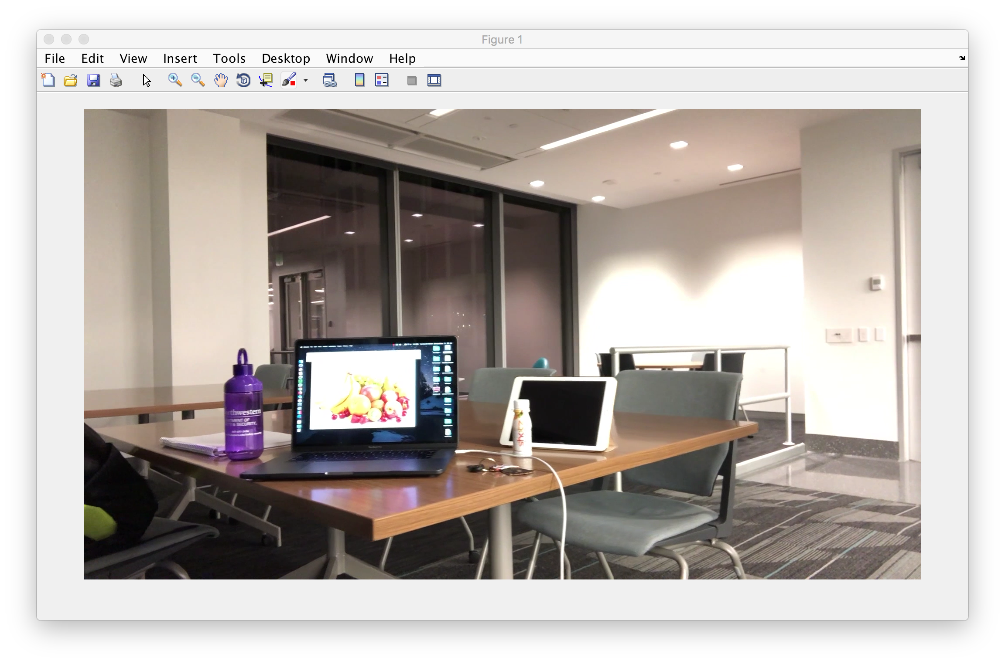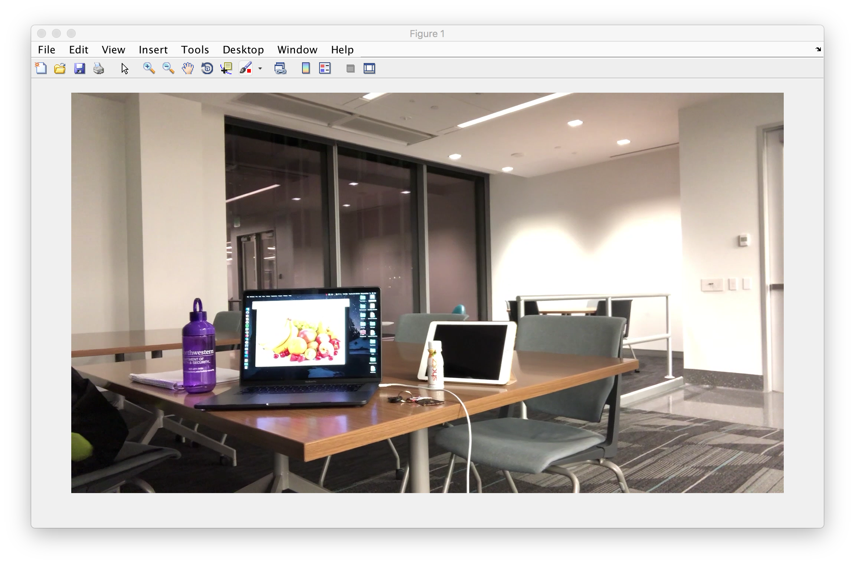

Frame 10

Frame 1

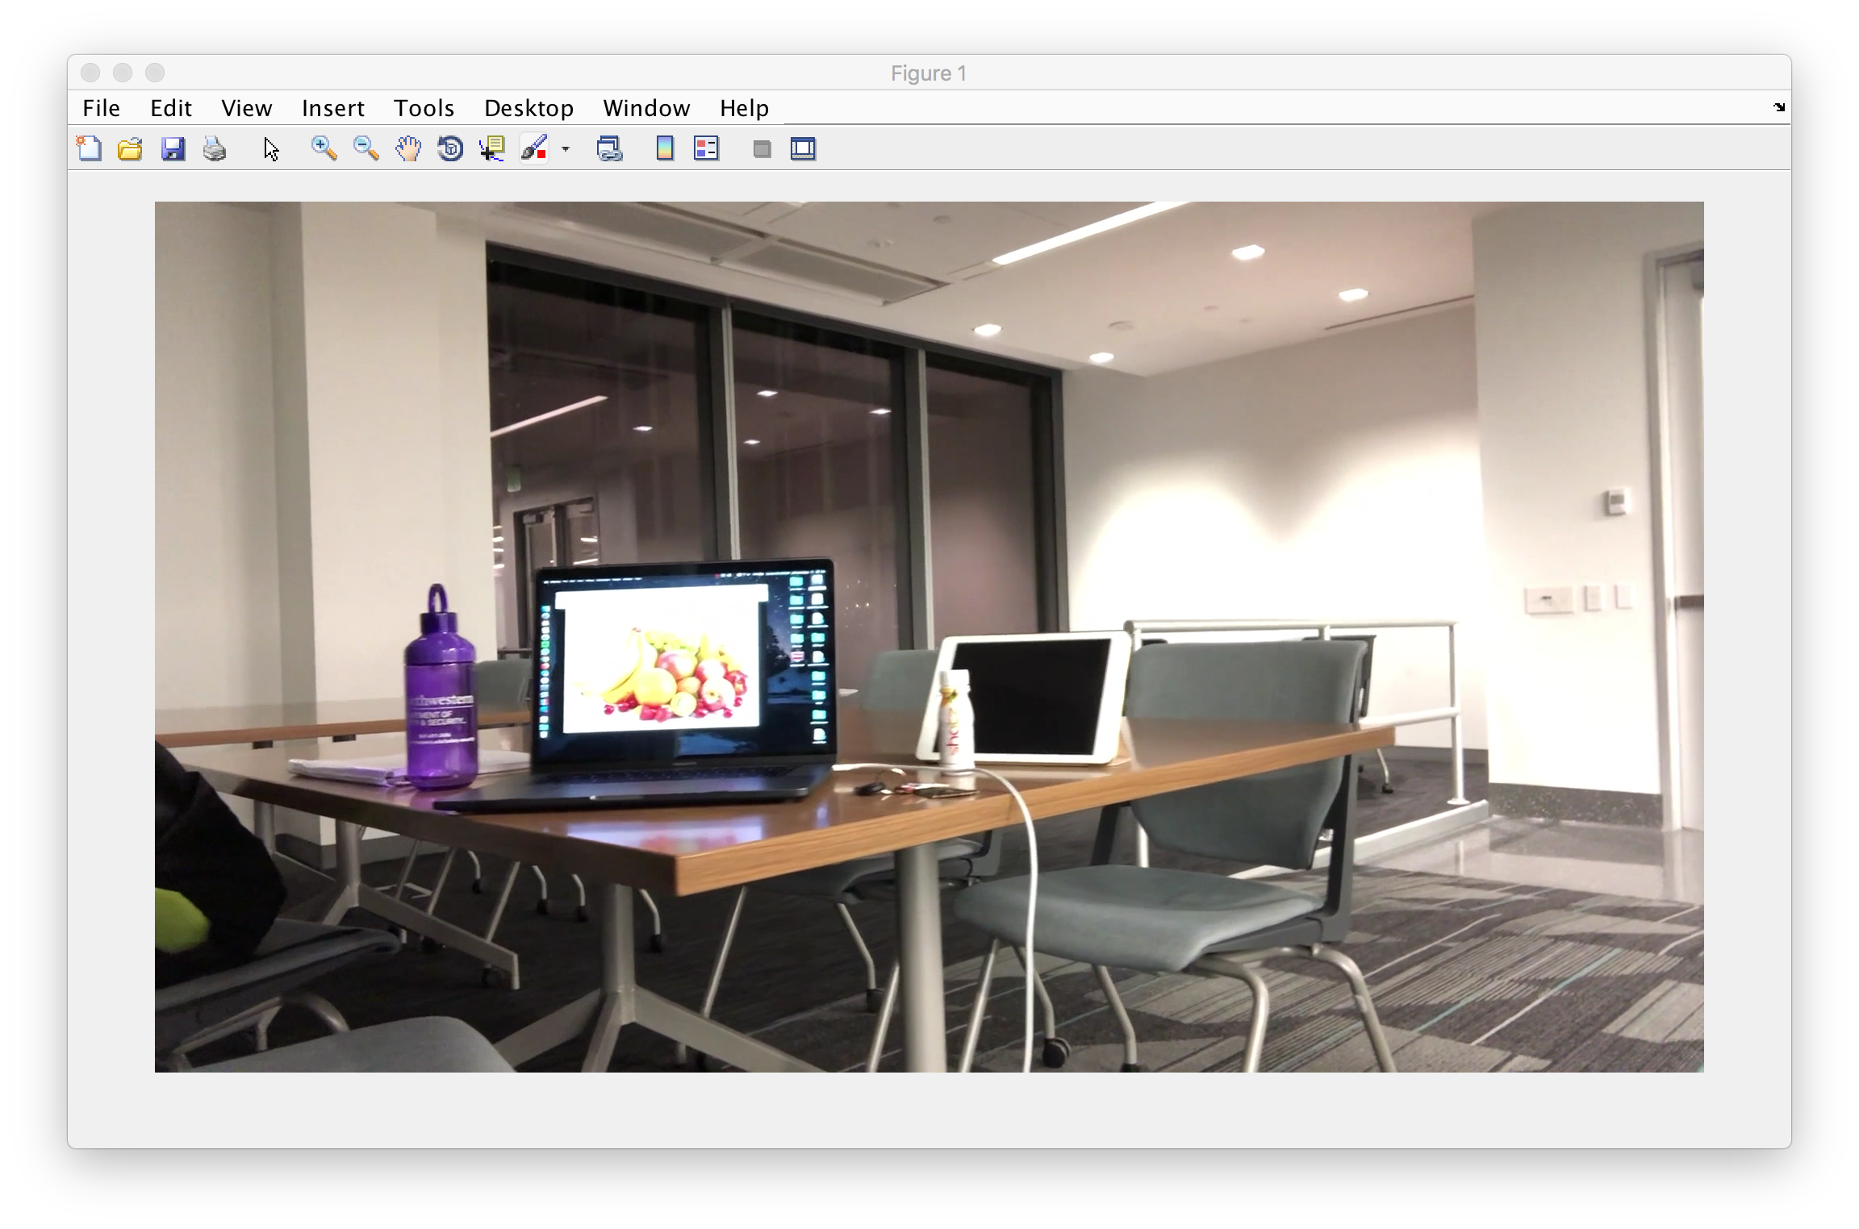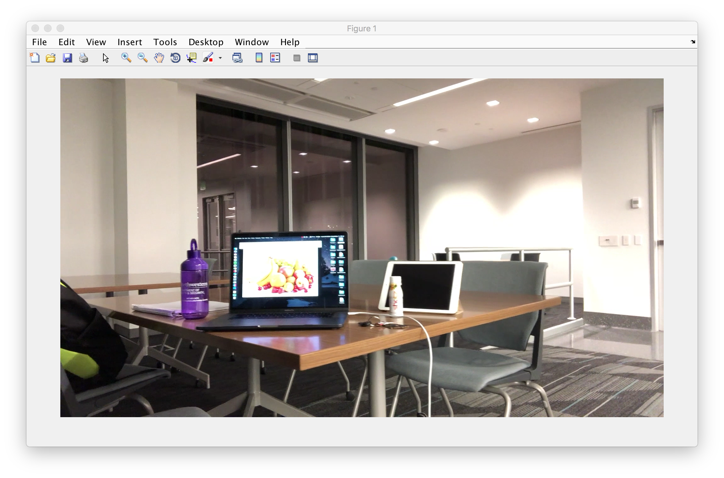

Frame 100

Frame 50

1. **Register the frames of video using template matching (5 points)**

Frame registration was done by creating a rectangular selection and processing its coordinates. Initially, the Northwestern Bottle is selected as the focus. Below is a screenshot of the rectangle selection operation and the **Normalized 2-D cross-correlation** function. It is a built-in function of Matlab Image Processing toolbox.

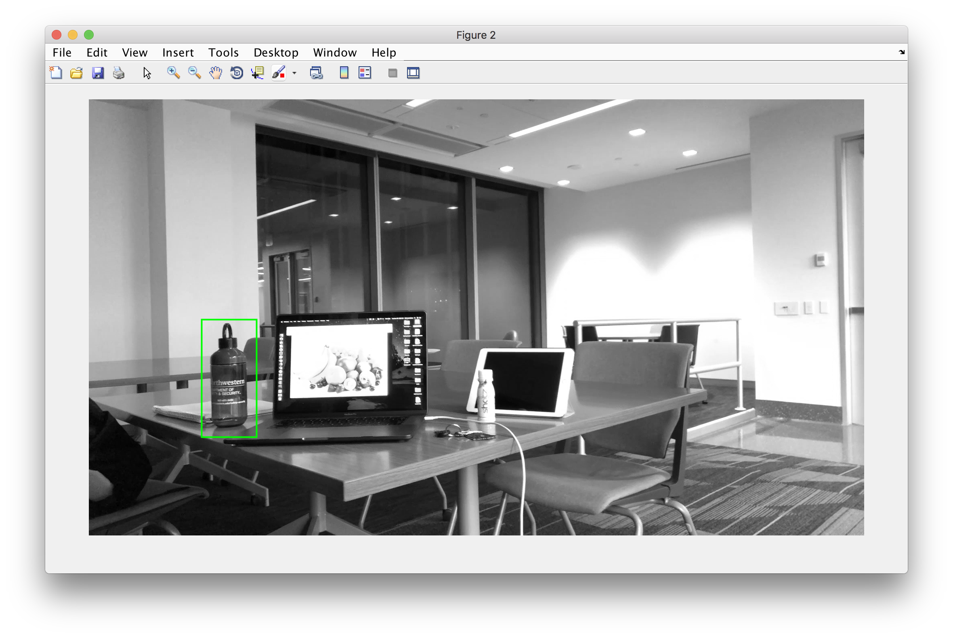

Green rectangle indicates the selected template.

Using the built-in *normxcorr2* function, it is capable of tracking and registering templates in all of the 120 frames. It has been employed here, instead of the *nfilter* function suggested in the question.

**Pixel shift** was calculated from the given equation. The following plot shows the pixel shift in each of the 120 frames of the video.

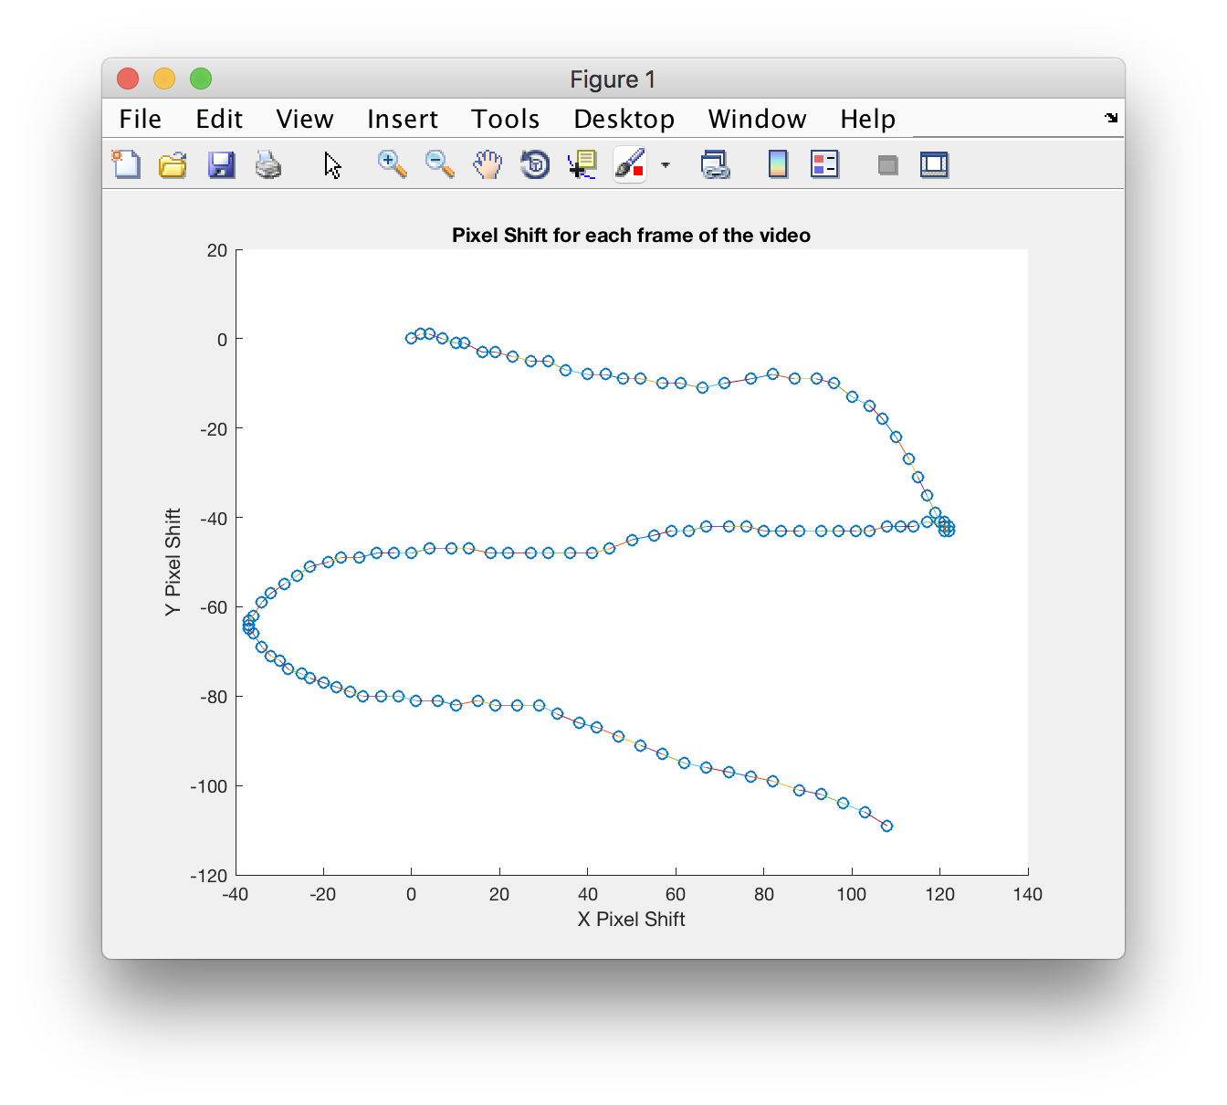

**Note:** Matlab Image Processing toolbox provides an excellent tool to estimate the pixel shift and to determine the registration. The following is an image of Maximally stable extremal regions (MSER) registration estimation.

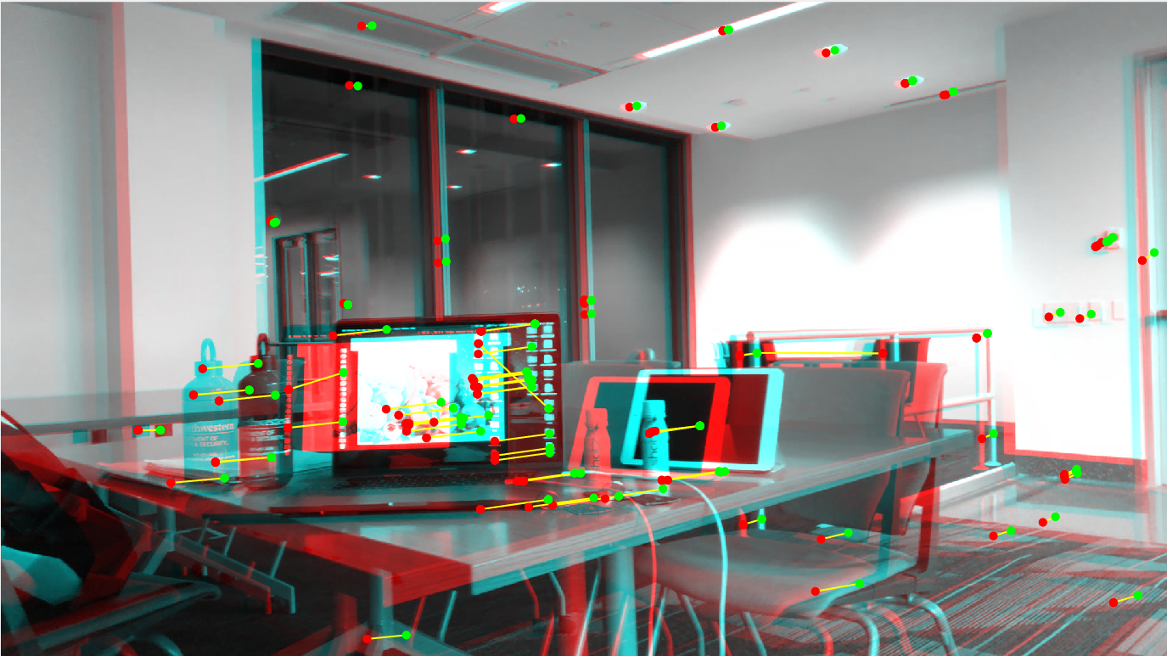

1. **Create a synthetic aperture photograph (5 points)**

The question has suggested to use *maketform* and *imtransform* functions to generate synthetic aperture photographs. As both of them are no more recommended by Matlab anymore, their successors, namely, *fitgeotrans* and *imwarp* has been employed here.

Additionally, *cpselect* or Control Point Selection Tool has been used to select control points in the related images, based on which we will generate the synthetic aperture photographs. A screenshot of this operation has been attached below. Here, the purple bottle is the object that the photograph will be centered on.

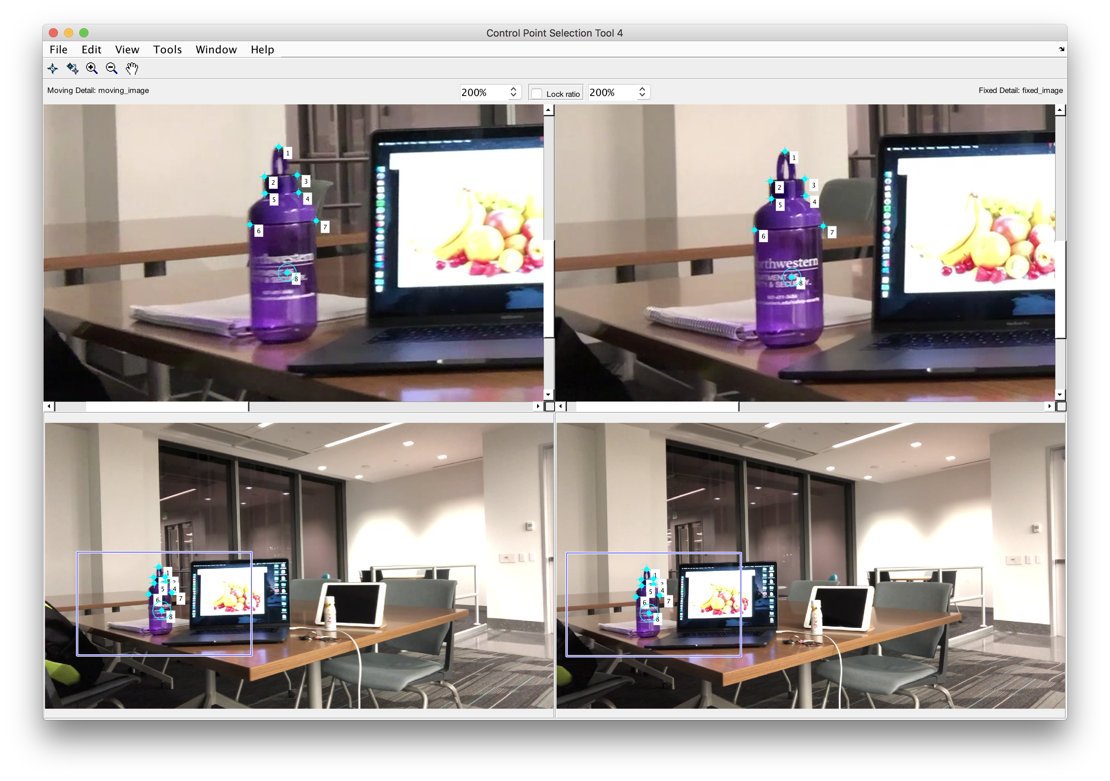

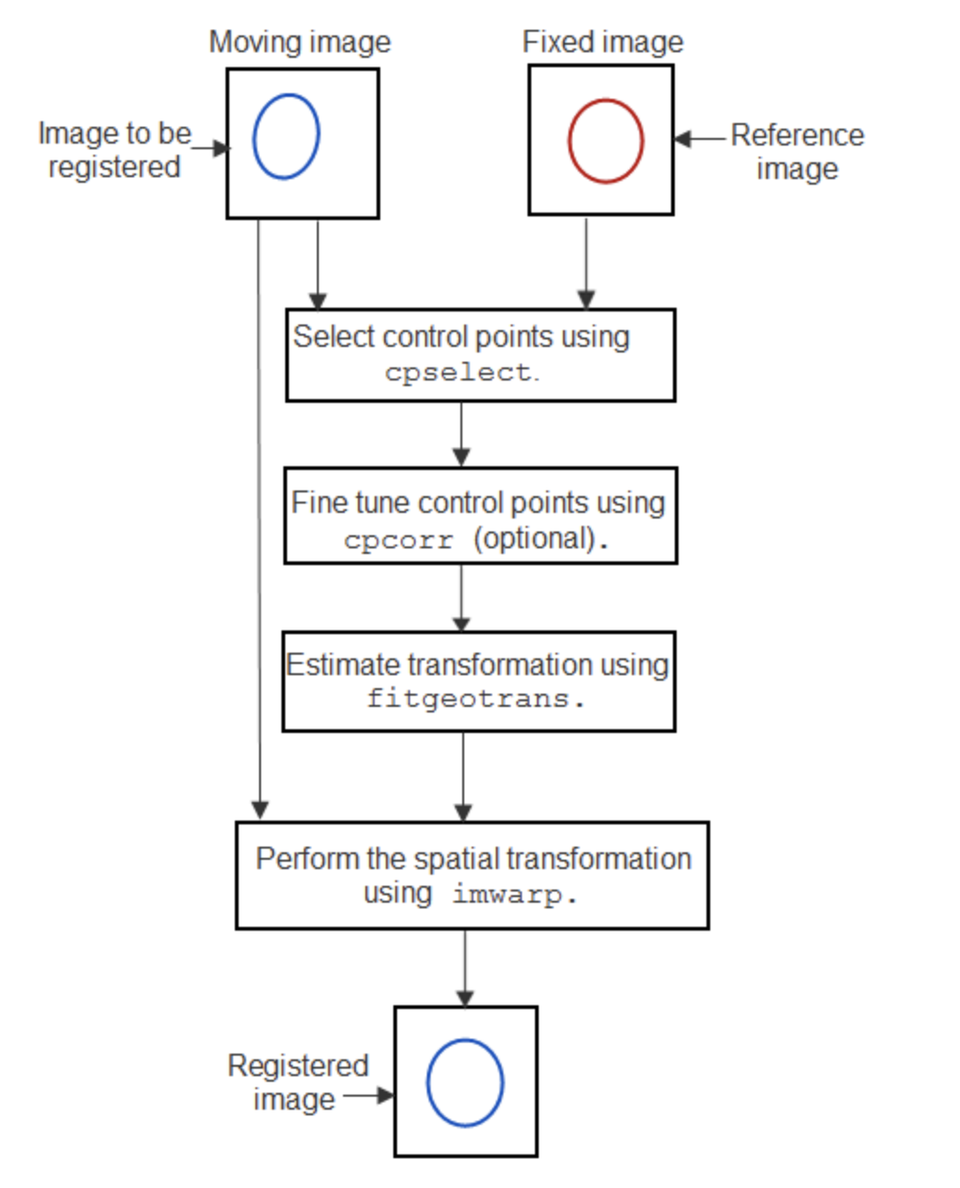

The process has been explained in the flowchart given on the right.

**Result** – Synthetic Aperture Photograph

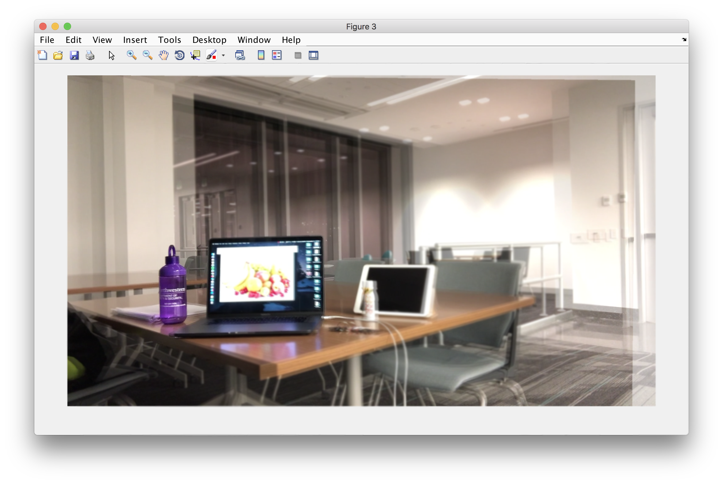

It can be observed that the purple bottle is in focus in the result. The iPad, laptop and background seems to be blurred/out of focus/distorted. A smooth blur is not observed here as only a few frames were selected in this operation to make the overall processing faster.

In the next section, different objects such as the iPad and the Laptop screen has been put into focus. The difference will be visible when compared with the results in the next stages.

1. **Refocus on a new object (2 points)**

Object in Focus: **iPad**

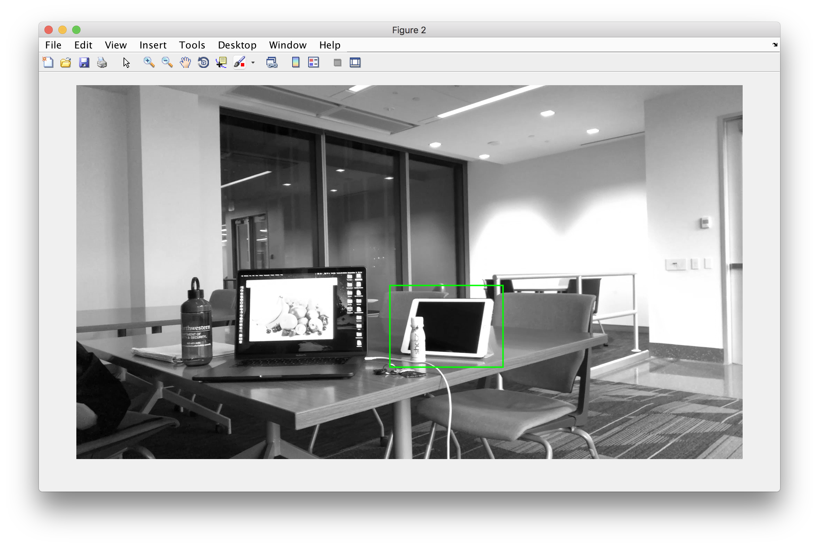

Template Selected

Result –Synthetic Aperture - iPad in focus

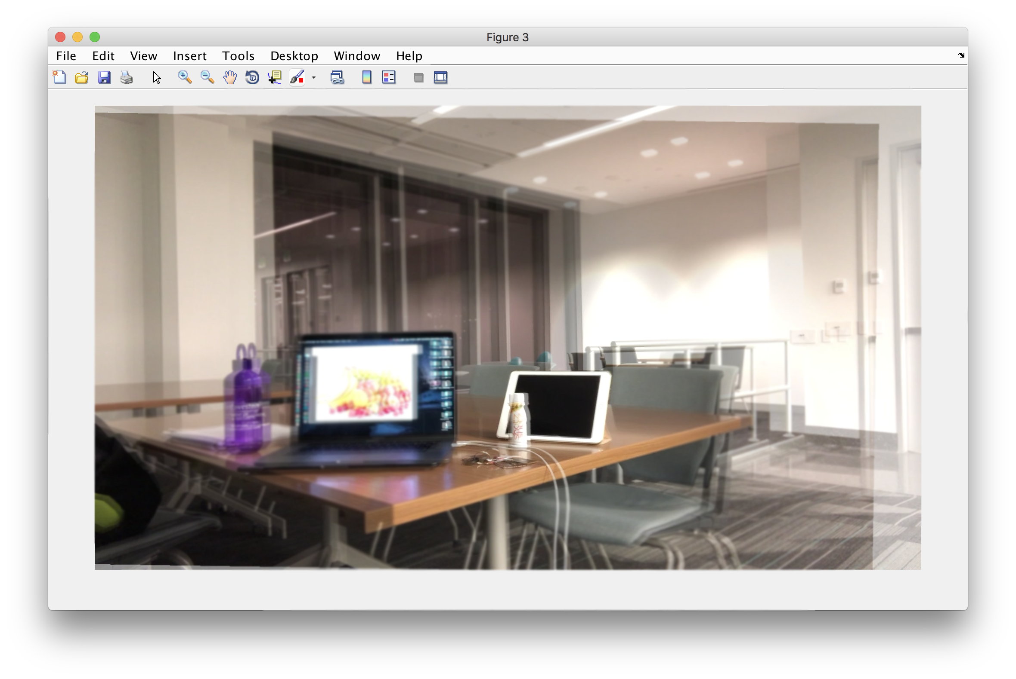

1. **Refocus on a new object**

Object in Focus: **Laptop Screen**

Template Selected

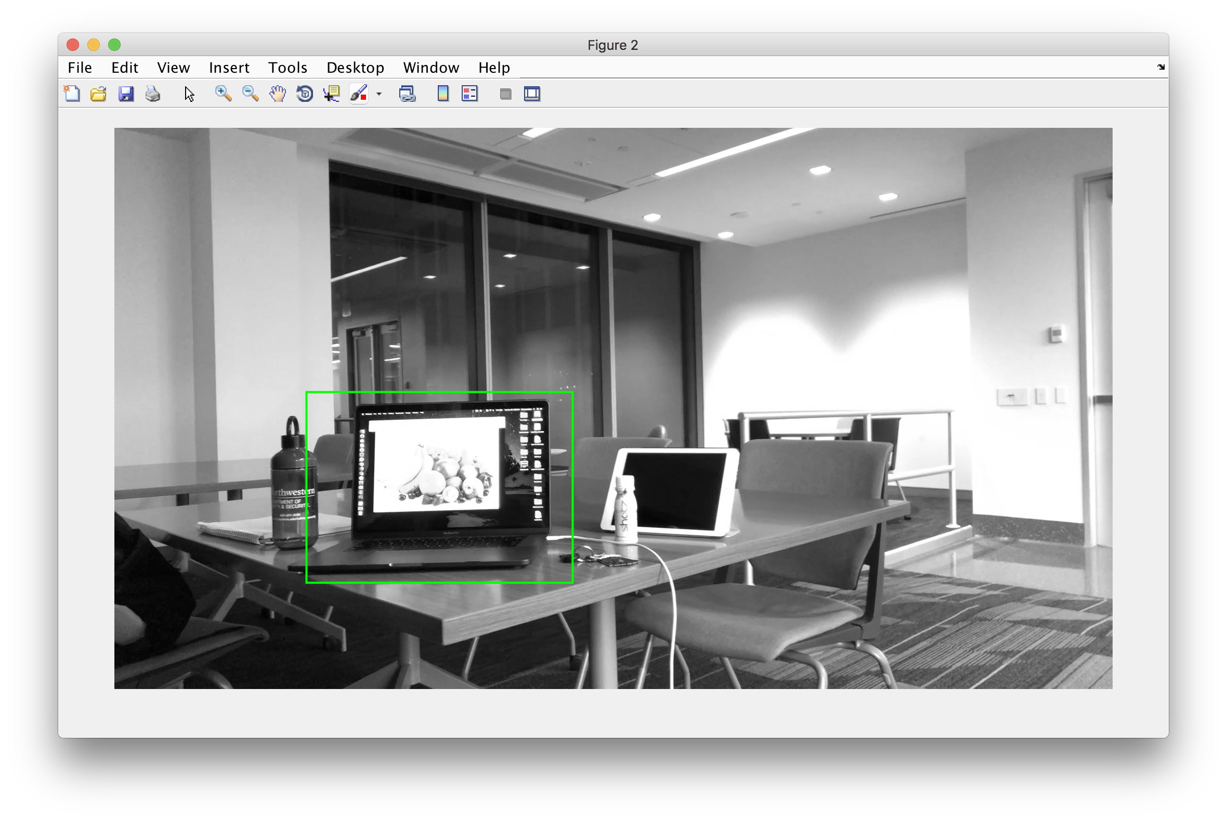

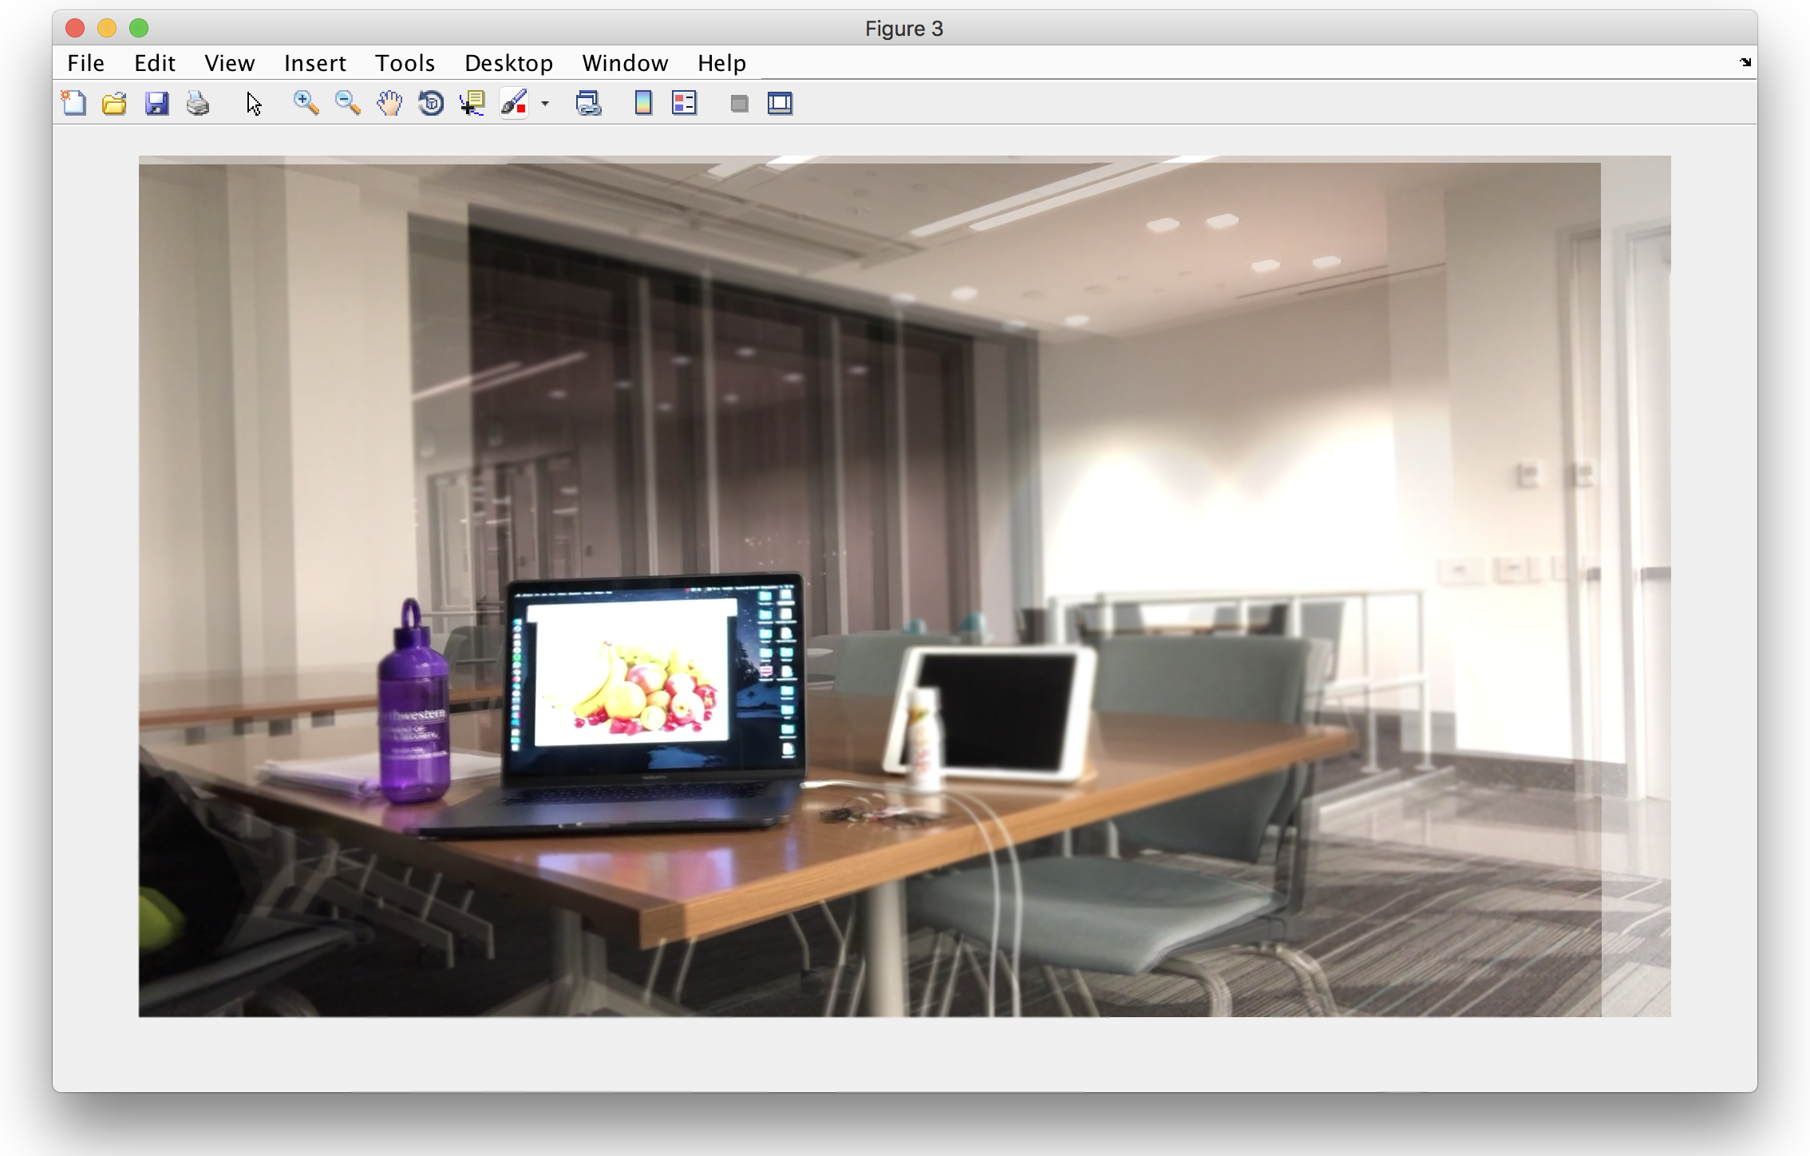

Result –Synthetic Aperture - iPad in focus